DATASHEET
BU-4062-M-XX-@ 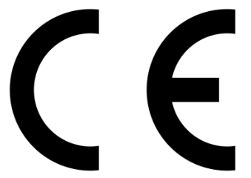
(UL® Listed Test Probe Silicone Wire)
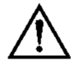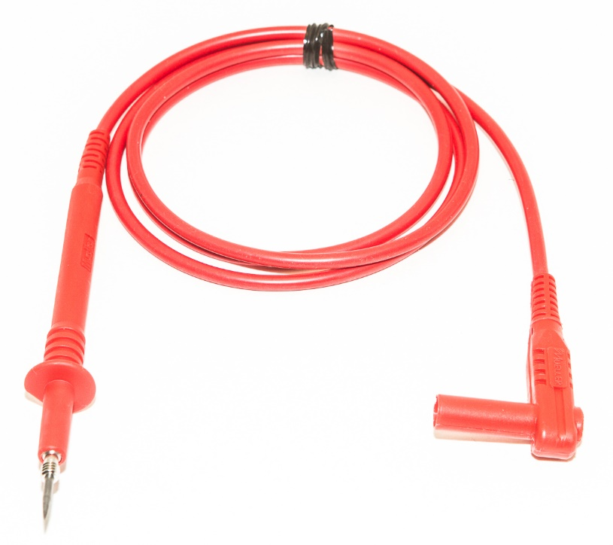
- 4mm, Right angle, shrouded, banana plug
- Uses 18 AWG (413/44) UL 3577, 105⁰C with a highly flexible silicone jacket.
- Length is designated in inches by the “XX” in the part number.
Standard lengths are: 12”, 18”, 24”, 39”, 48”, 60” and 72”
- Material: Probe – Stainless Steel, #8-32 threads for attachments
Banana Plug – Nickel plated Beryllium Copper and Brass
Cover -- Polypropylene
- Ratings:
  - Operating Voltage: 1,000V
  - Measurement Category: CAT II
  - Current: 20 Amps
  - Operating Temperature: -40°C to 60°C, 80% Max relative humidity.
  - Pollution Degree 2
  - Hands free testing to 3,000V
- Color: The “@” in the model number represents color. Available colors:
-0 Black, -2 Red, -4 Yellow, -5 Green, -6 Blue, -8 Gray, -9 White
- RoHS 3 Compliant, Certified
- Cleaning instructions- use soap and water or alcohol, wipe clean.
- Only use this test lead in the manner it is intended, do not use it for any other purpose. Always check for wear and or breaks in the wire before use.
- 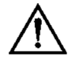 If you see this symbol on a probe, please refer to the datasheet before use. Means “Caution.”
- CAT II rating is applicable to test and measuring circuits connected directly to utilization points (socket outlets and similar points) of the low-voltage mains installation.

